**Project 01 Decision Tree (Titanic Dataset)**

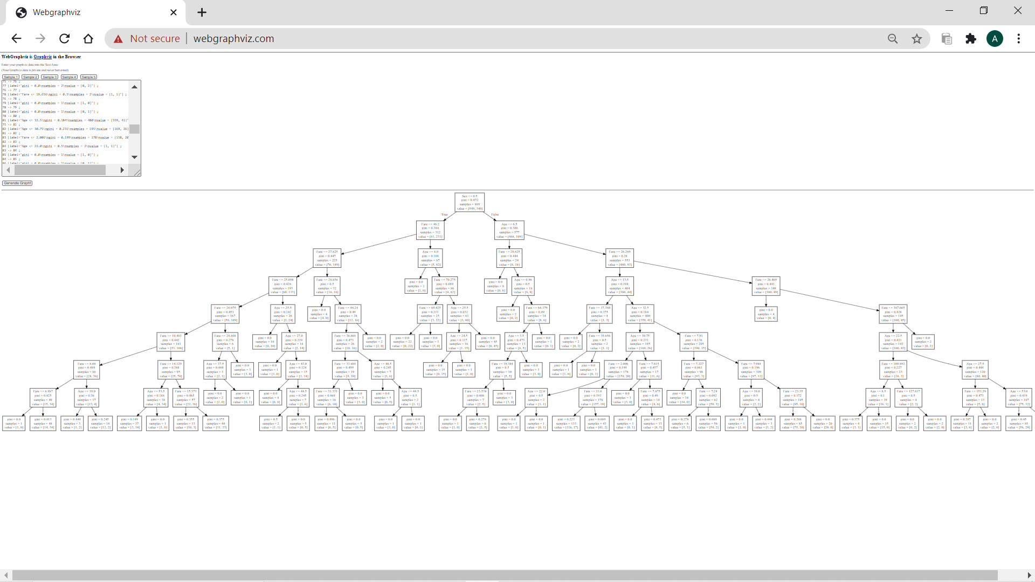

**Project 02 Decision Tree (Attrition Rate Analysis)**

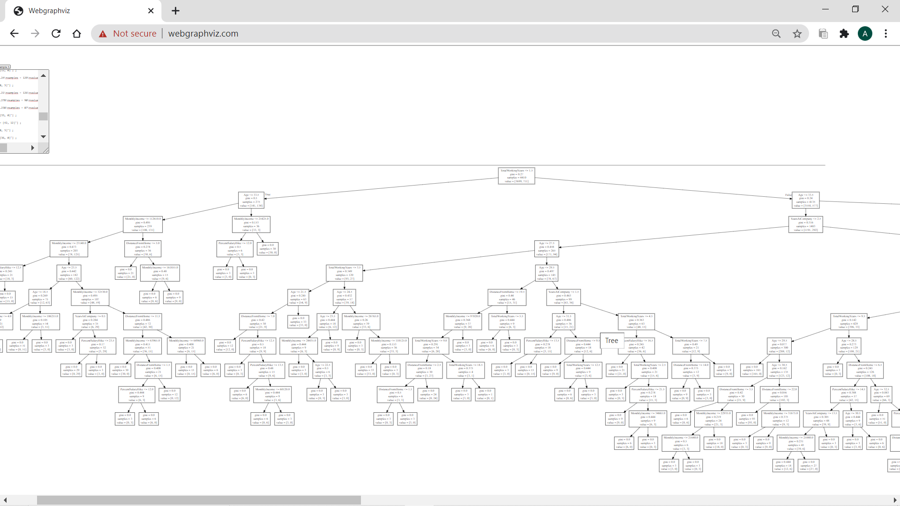

**Project 03 Decision Tree(Bank loan)**

